Task 1: For Loop
- Create for_loop.sh that:
  - Loops through a list of 5 fruits and prints each one
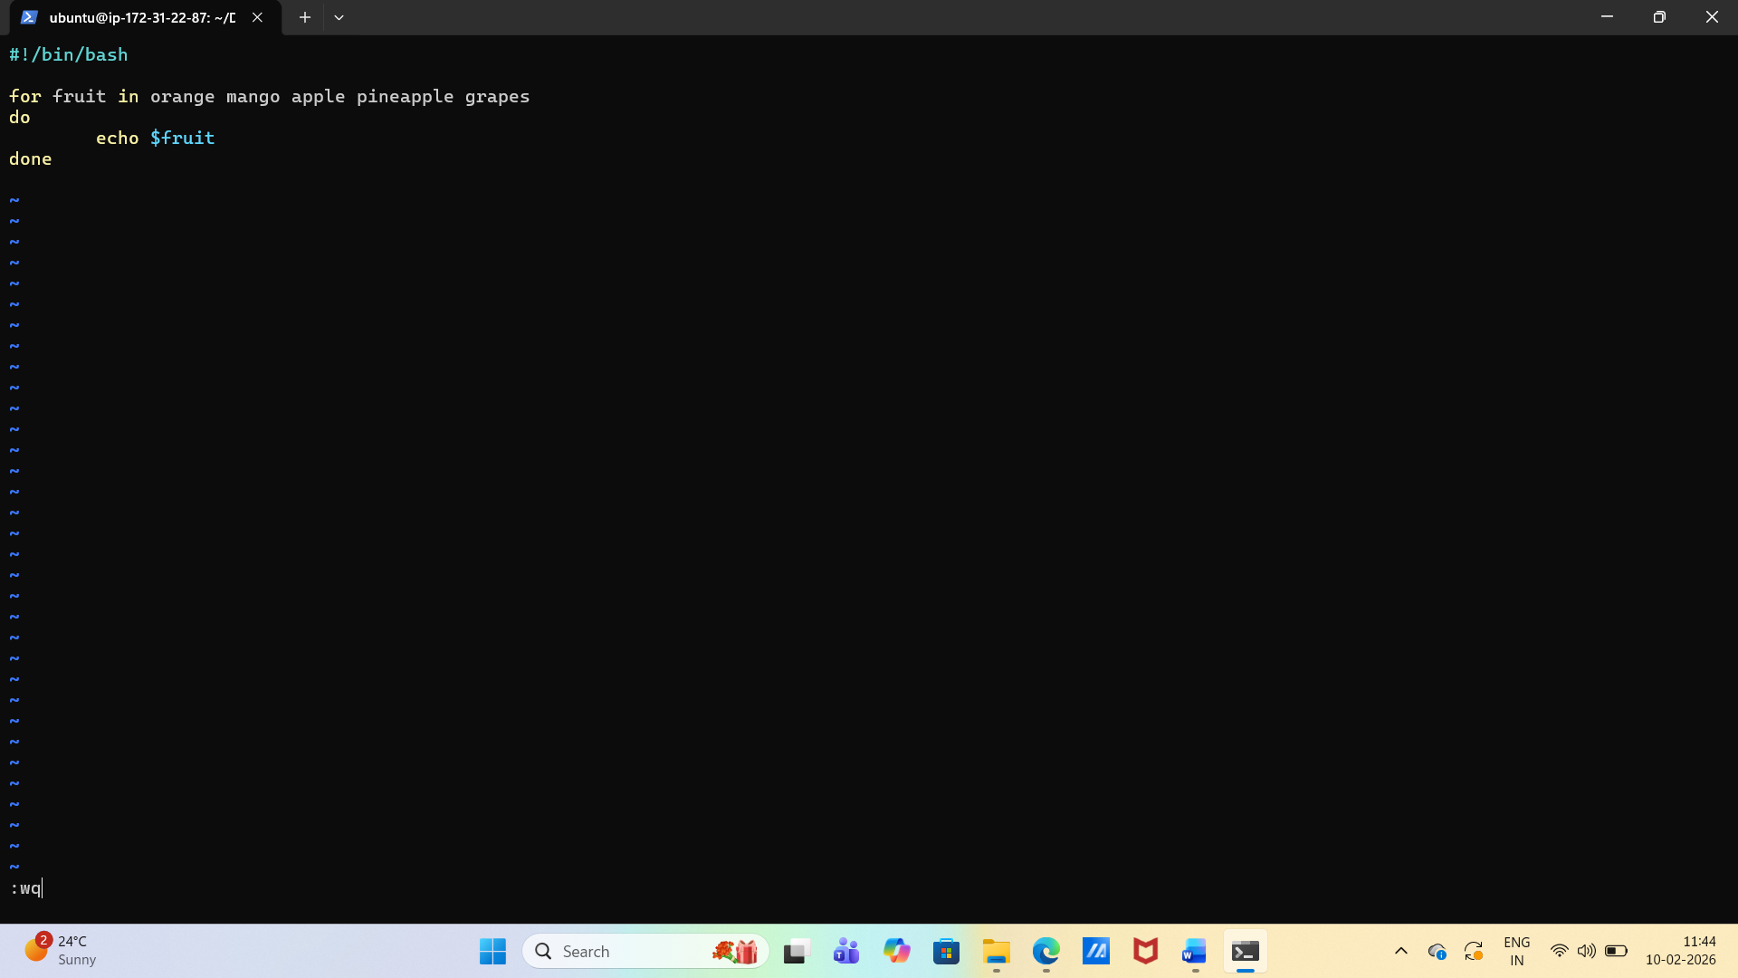
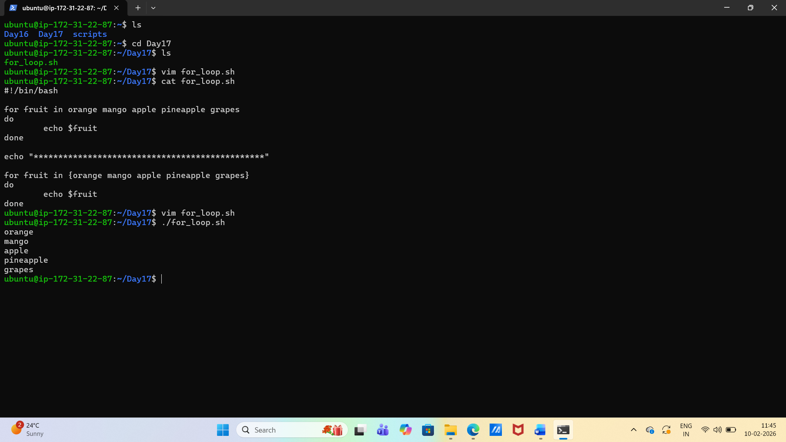

- Create count.sh that:
  - Prints numbers 1 to 10 using a for loop

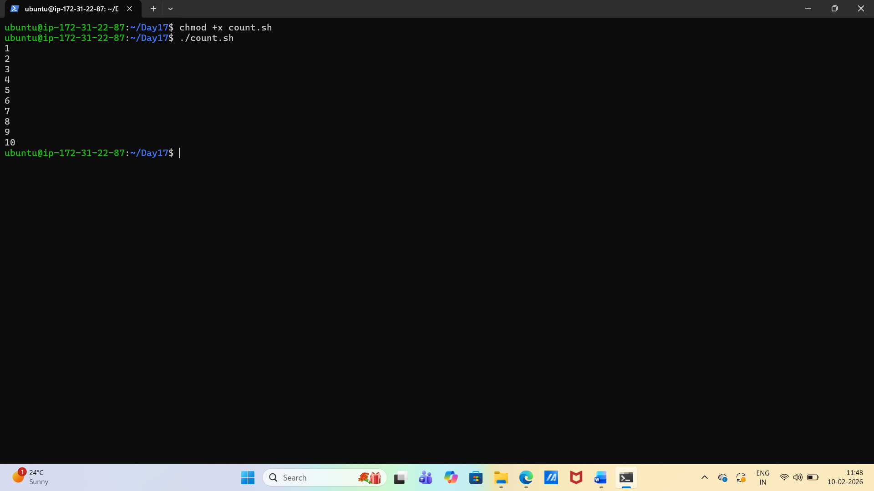
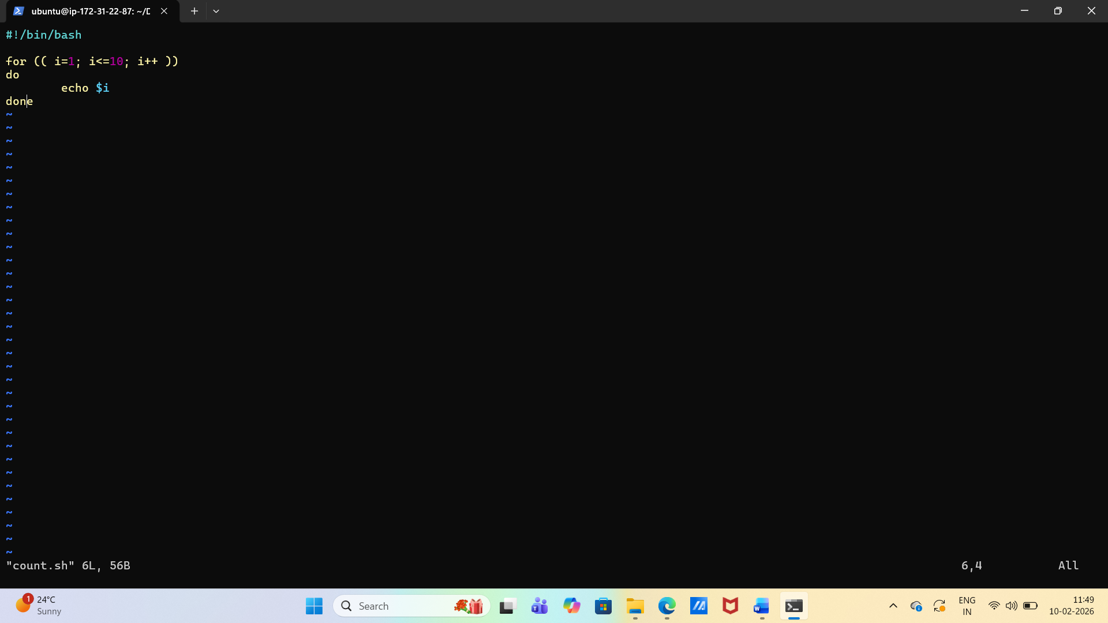

Task 2: While Loop
- Create countdown.sh that:
  - Takes a number from the user
  - Counts down to 0 using a while loop
  - Prints "Done!" at the end

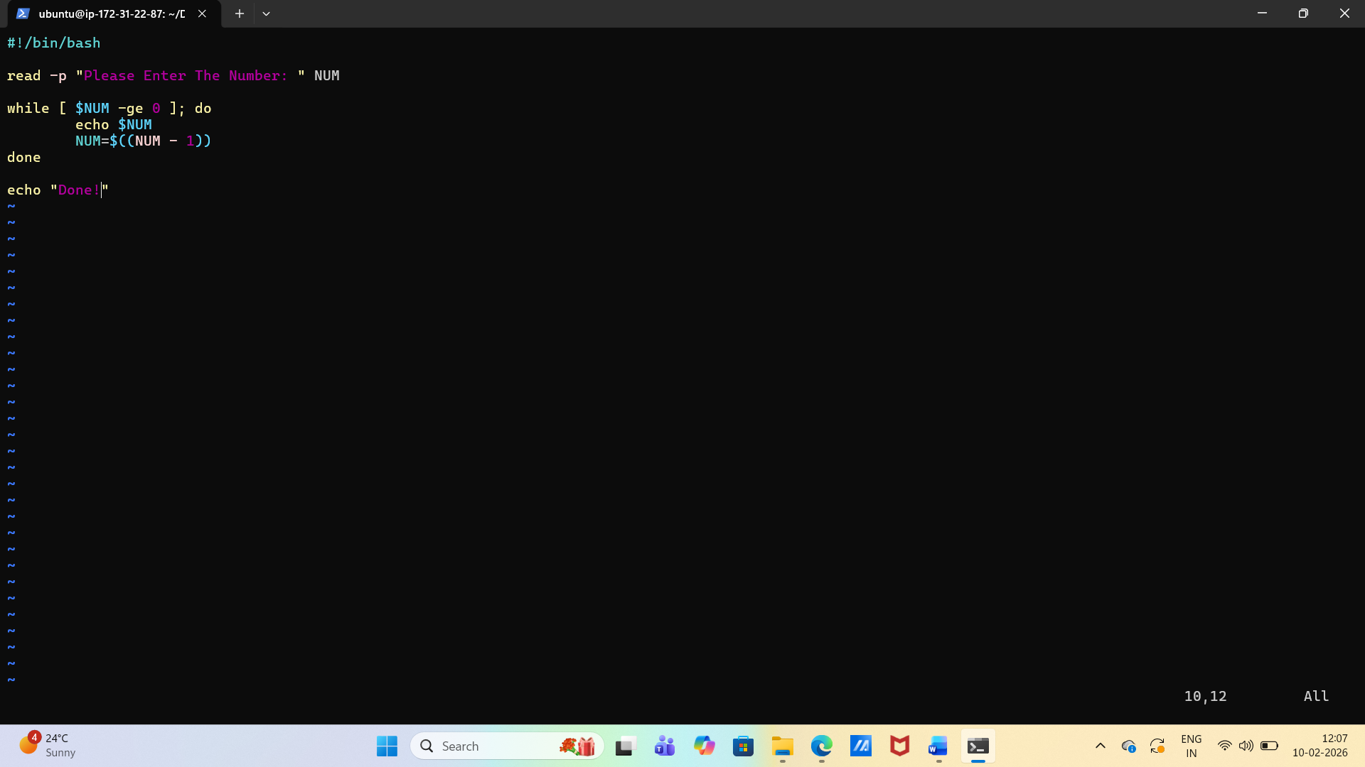

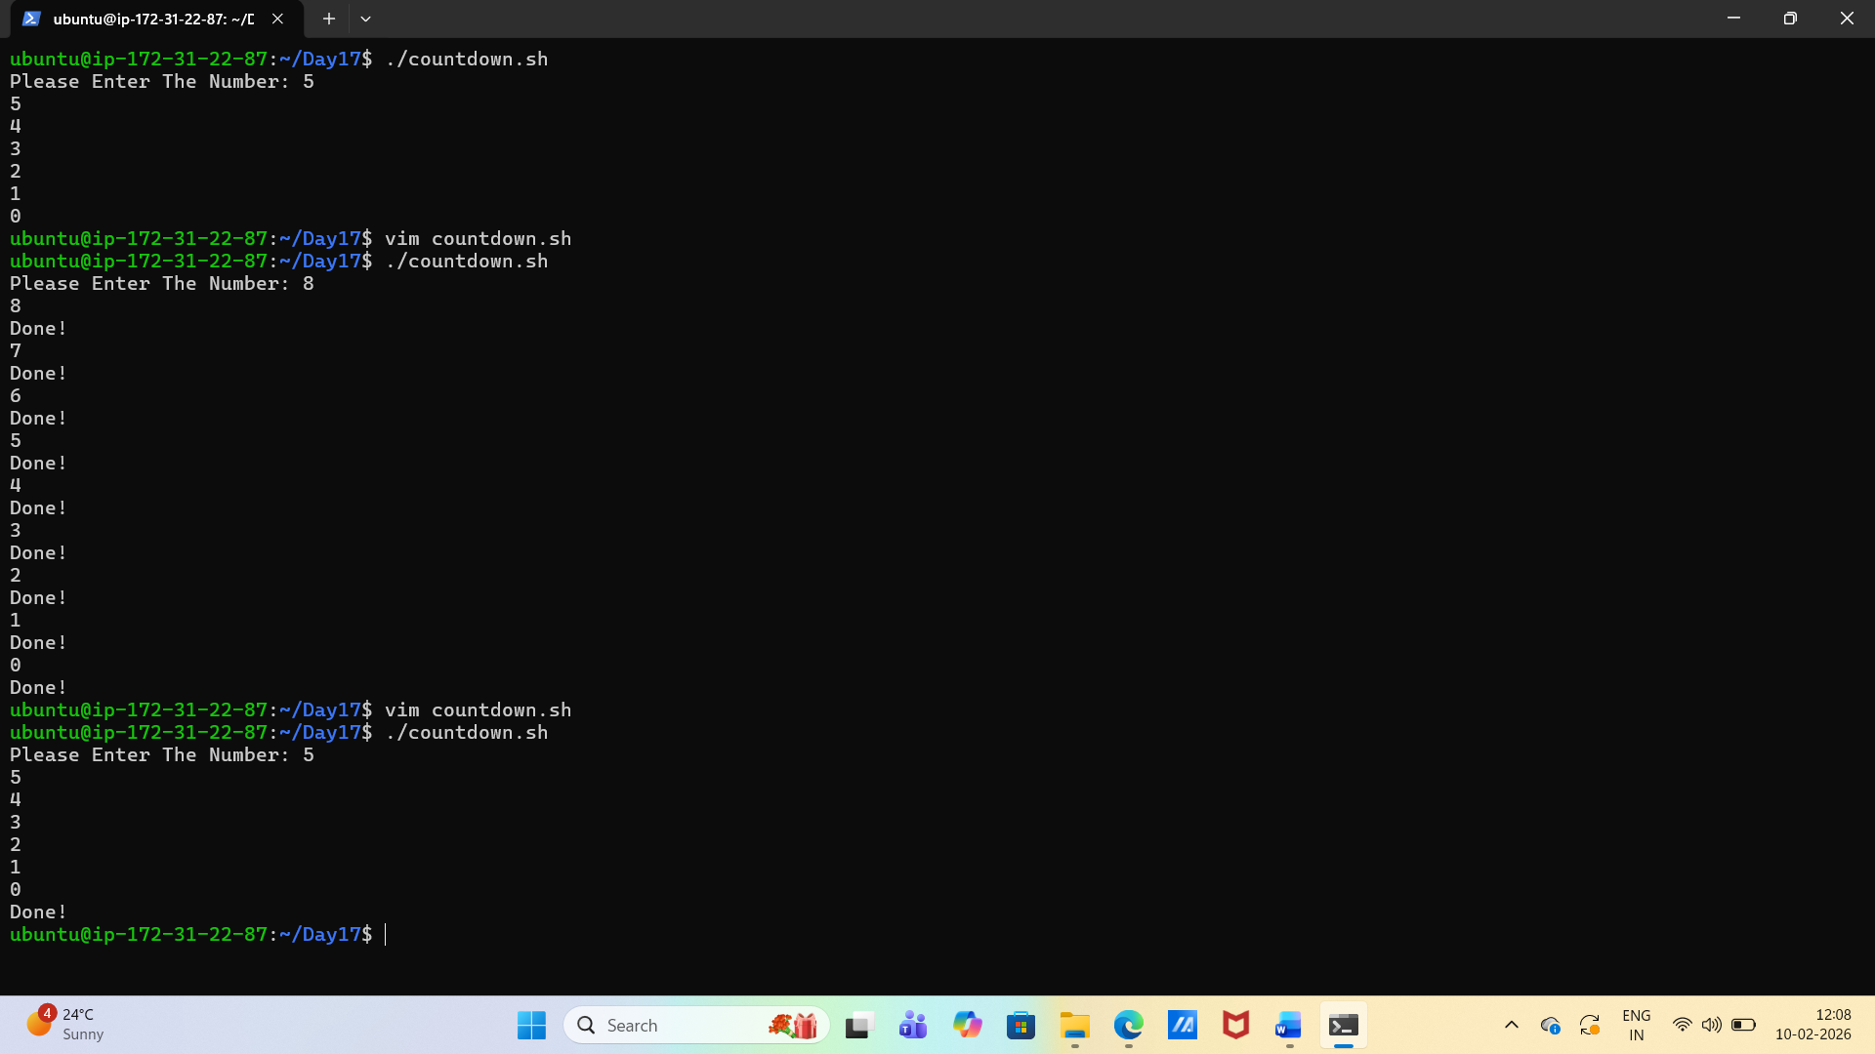

Task 3: Command-Line Arguments
- Create greet.sh that:
  - Accepts a name as $1
  - Prints Hello, <name>!
  - If no argument is passed, prints "Usage: ./greet.sh "
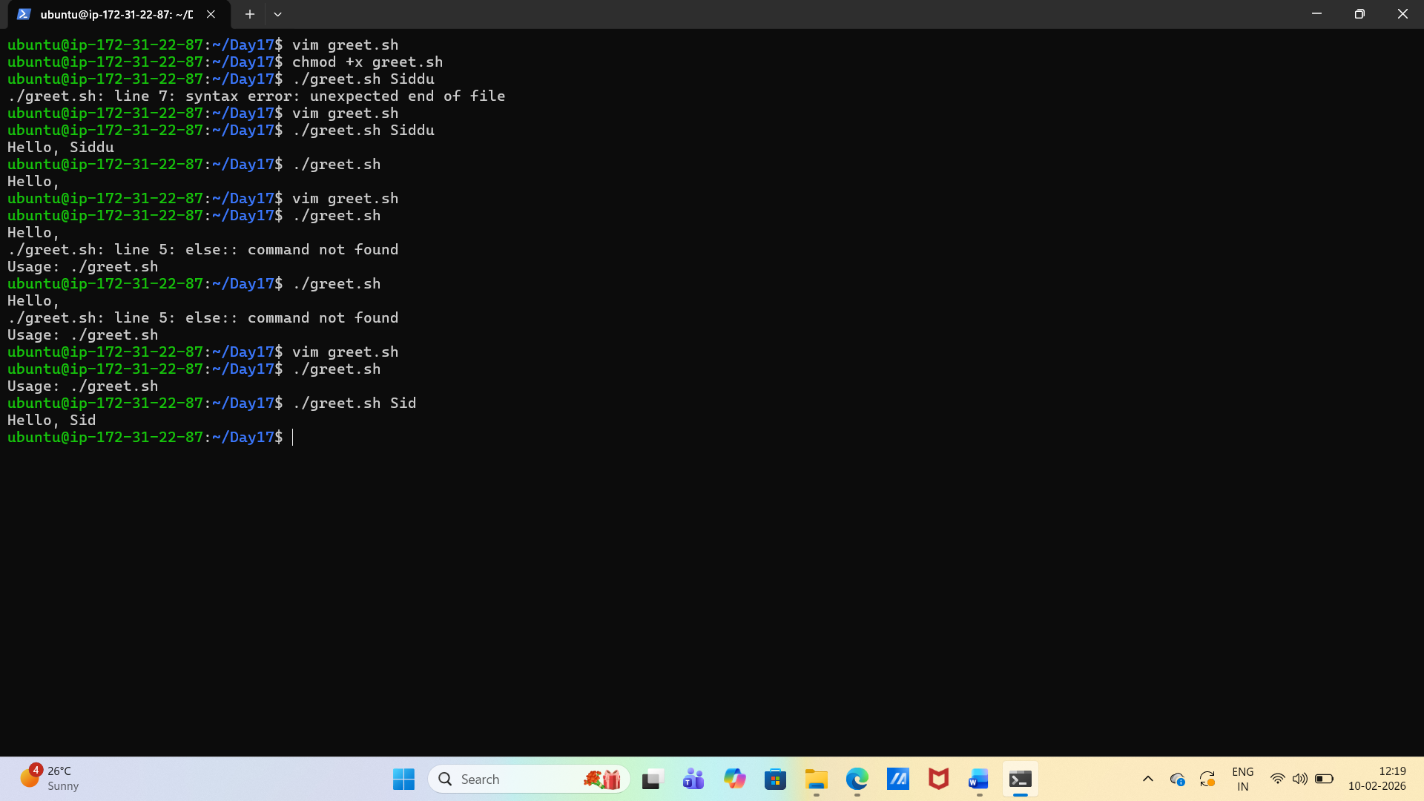
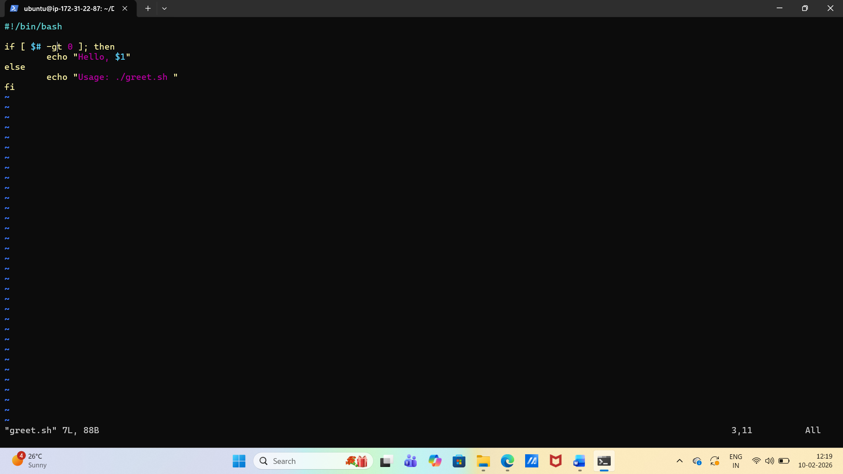
- Create args_demo.sh that:
  - Prints total number of arguments ($#)
  - Prints all arguments ($@)
  - Prints the script name ($0)
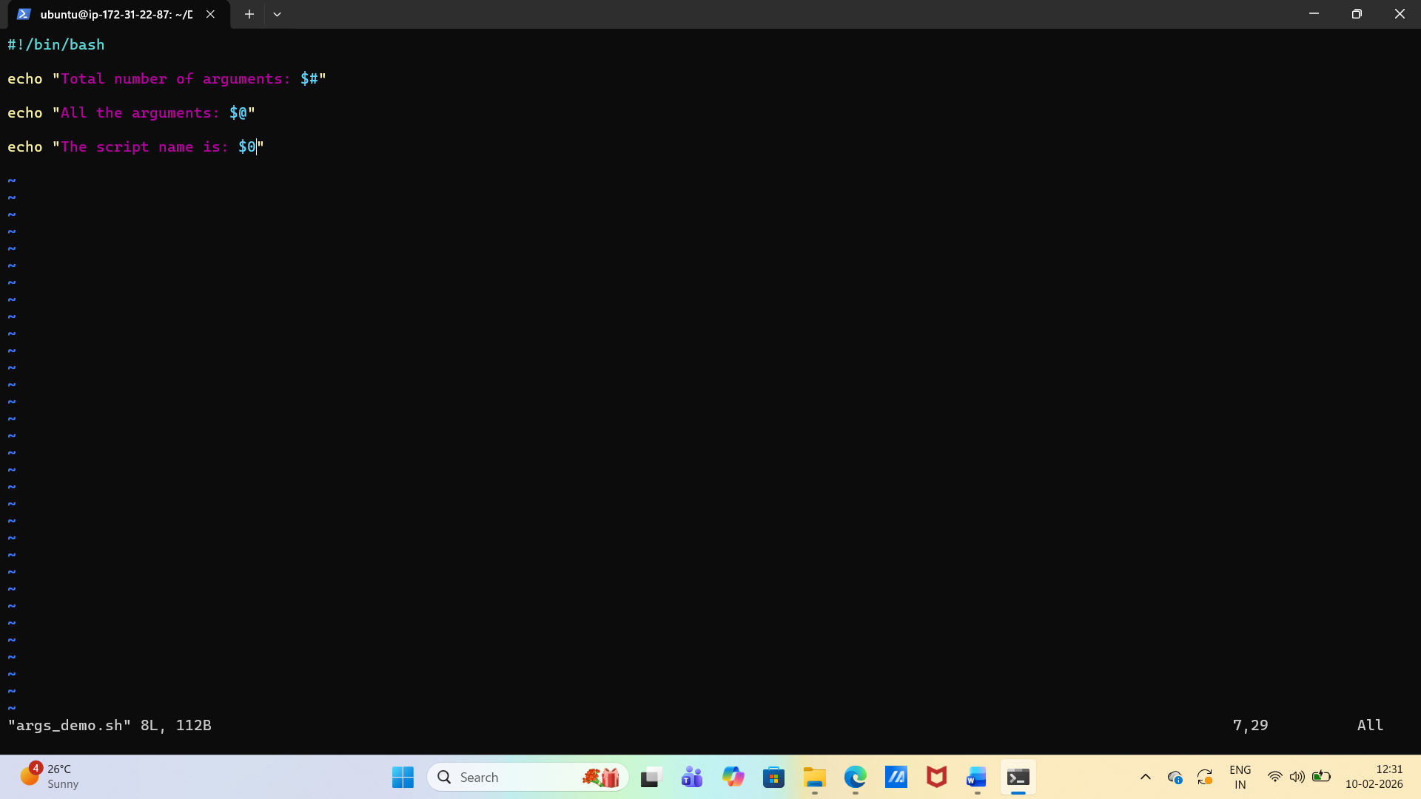
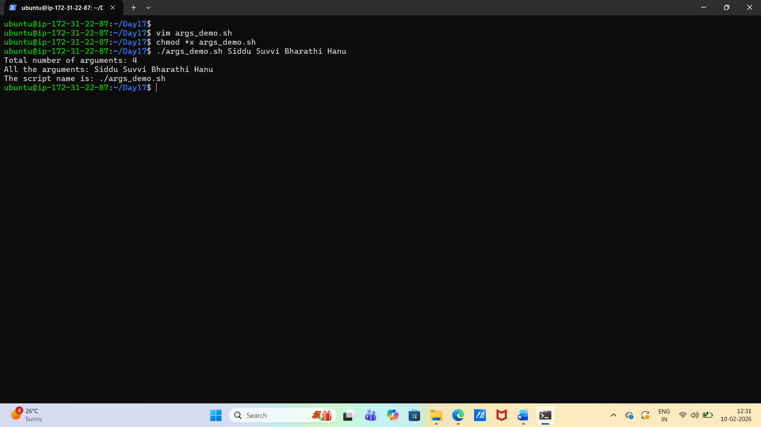

Task 4: Install Packages via Script
- Create install_packages.sh that:
  - Defines a list of packages: nginx, curl, wget
  - Loops through the list
  - Checks if each package is installed (use dpkg -s or rpm -q)
  - Installs it if missing, skips if already present
  - Prints status for each package
Run as root: sudo -i or sudo su
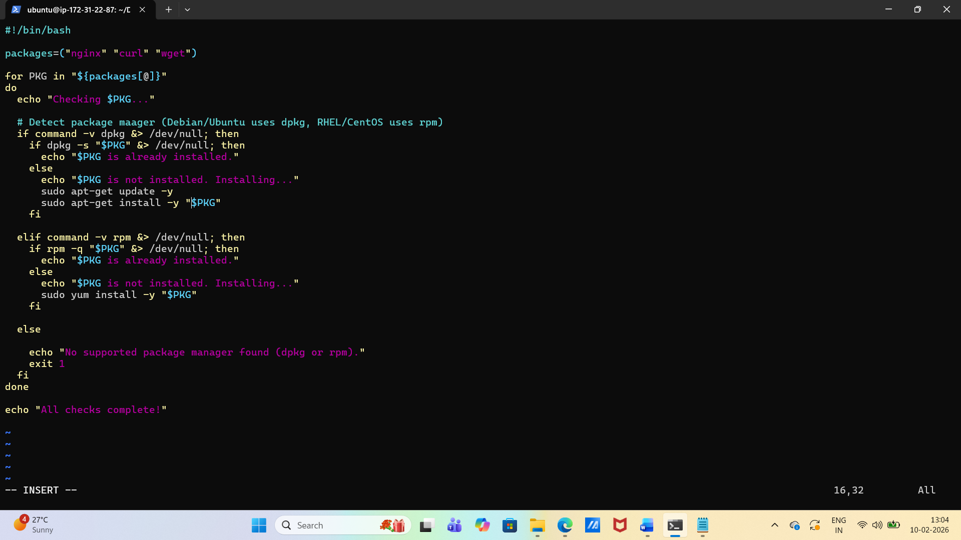
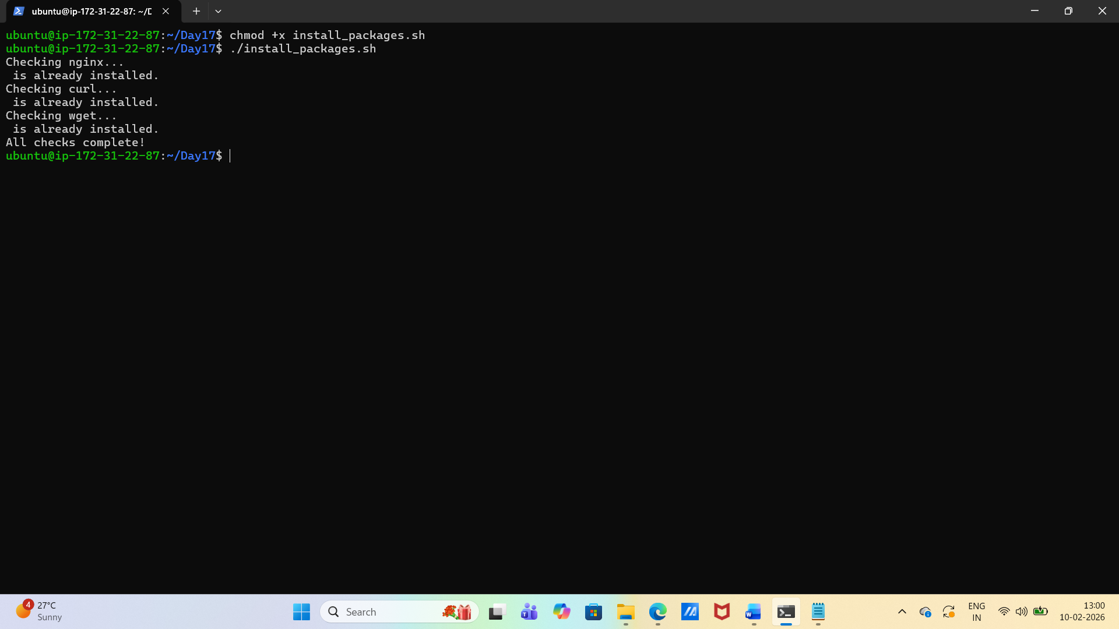

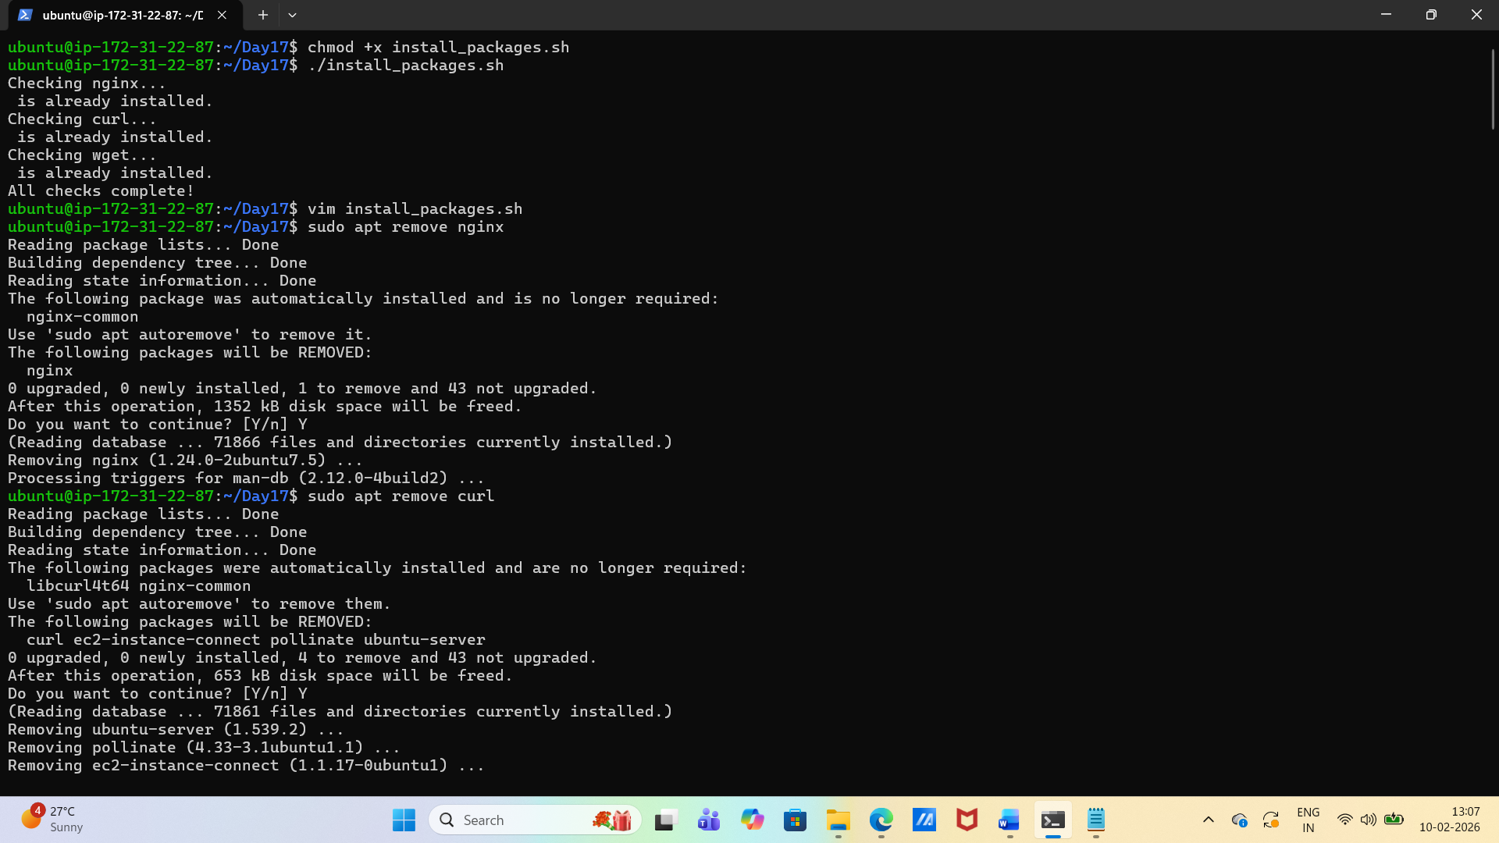

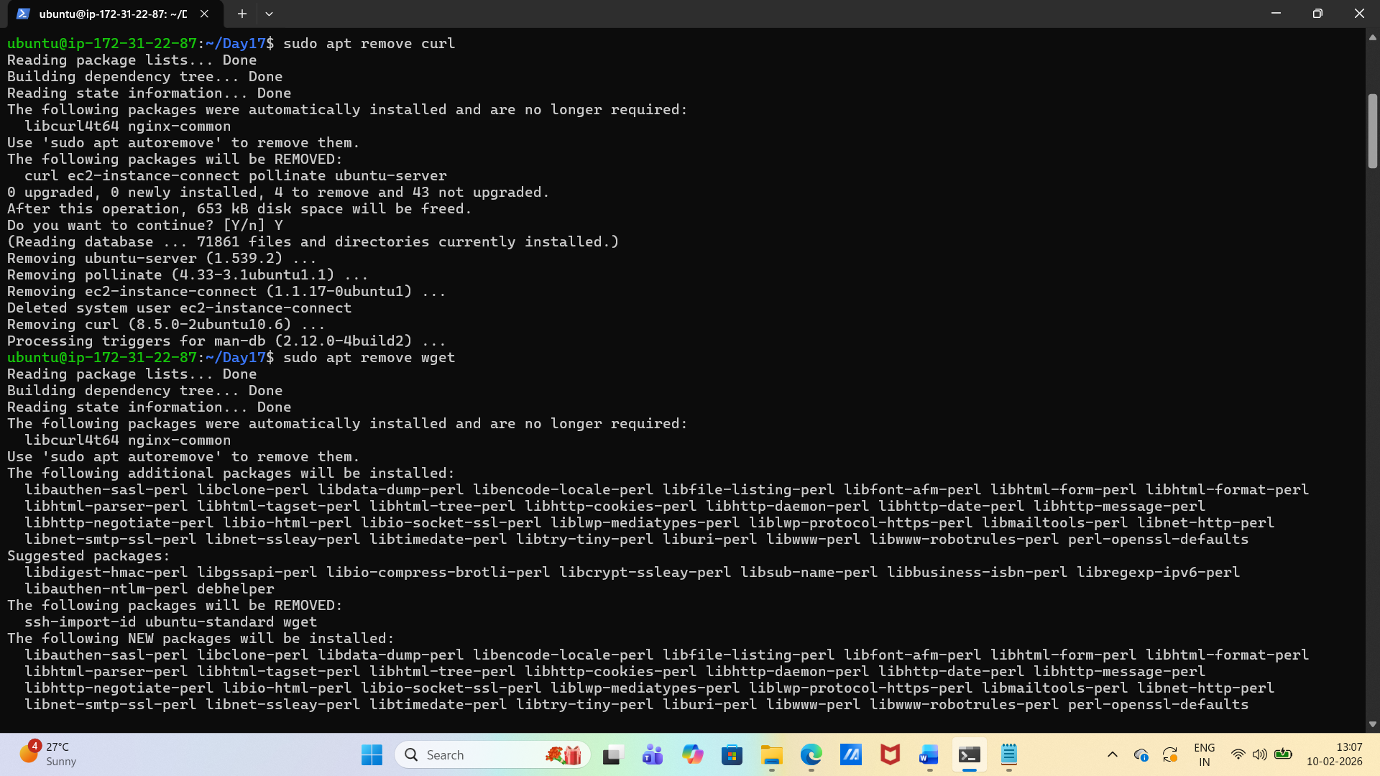

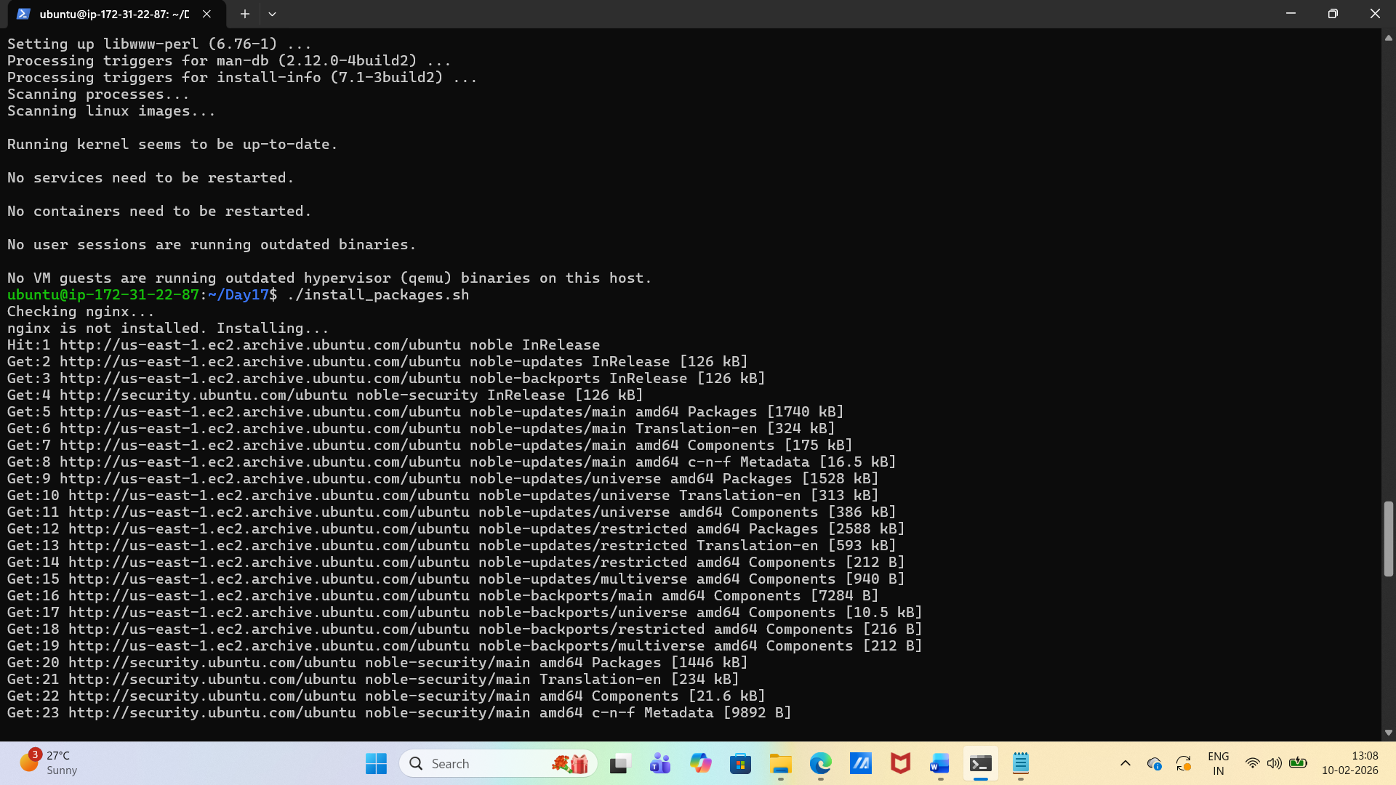

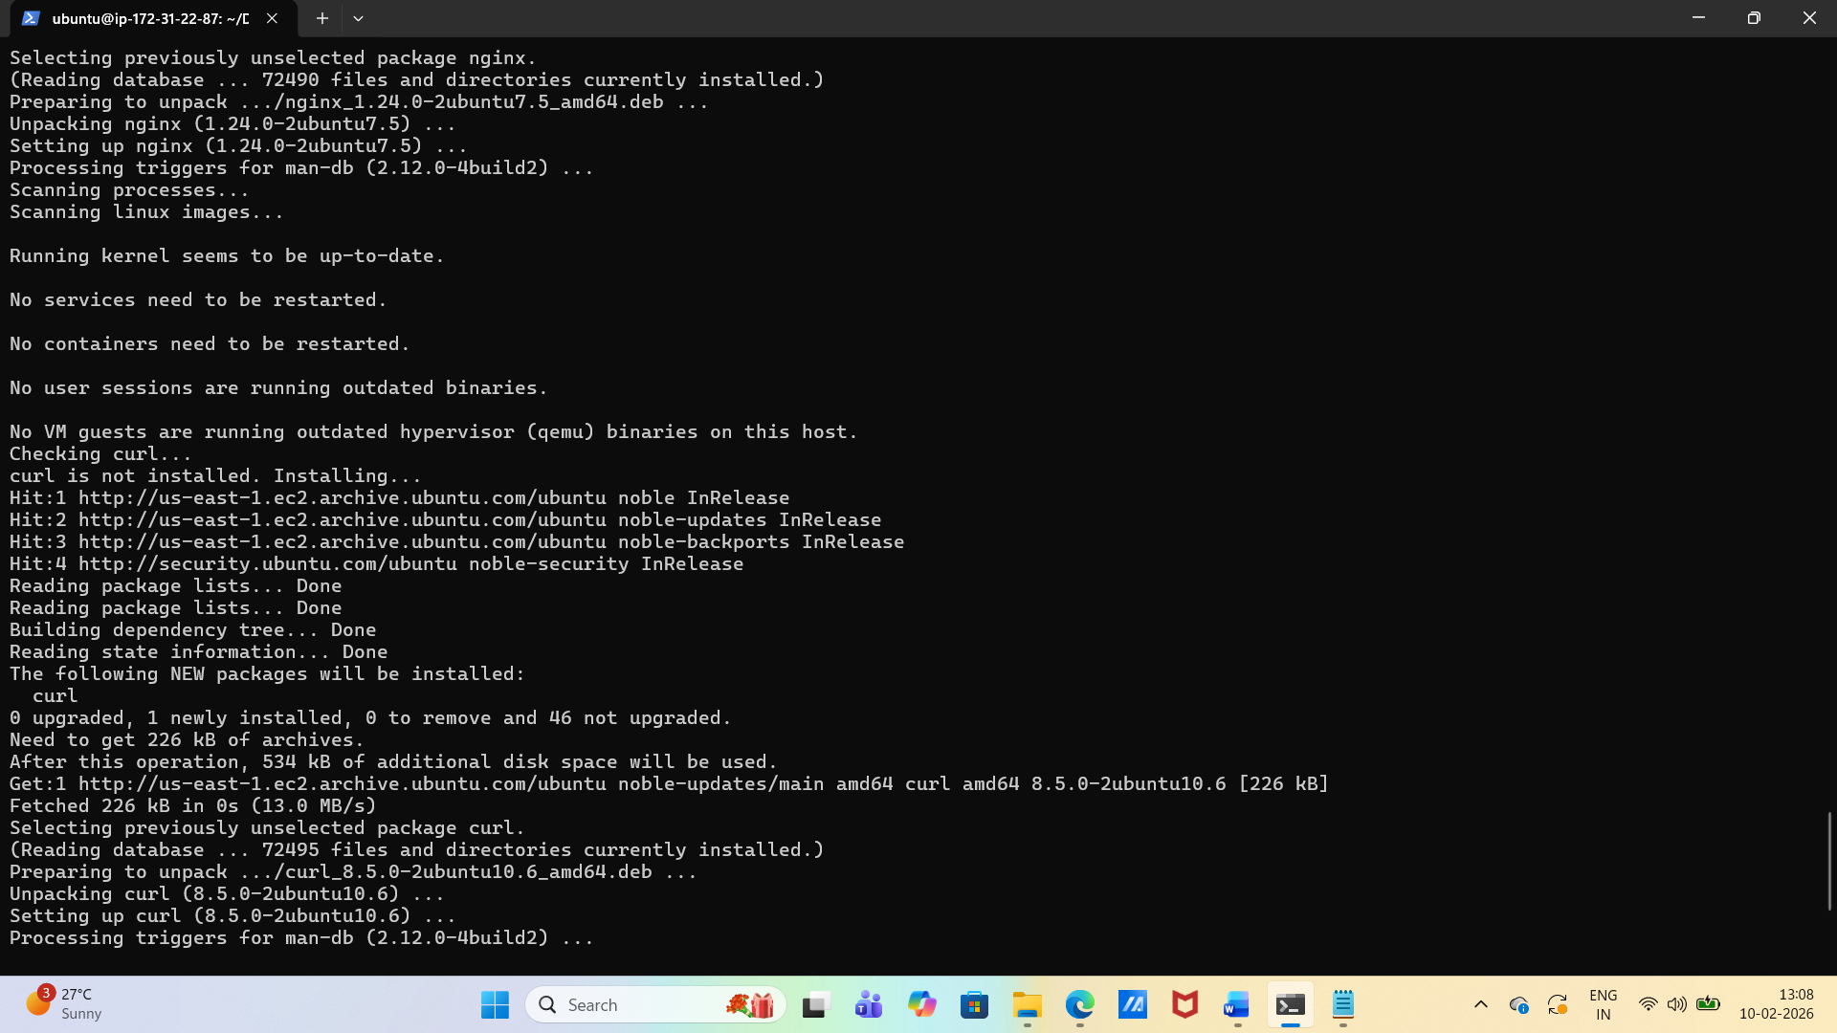

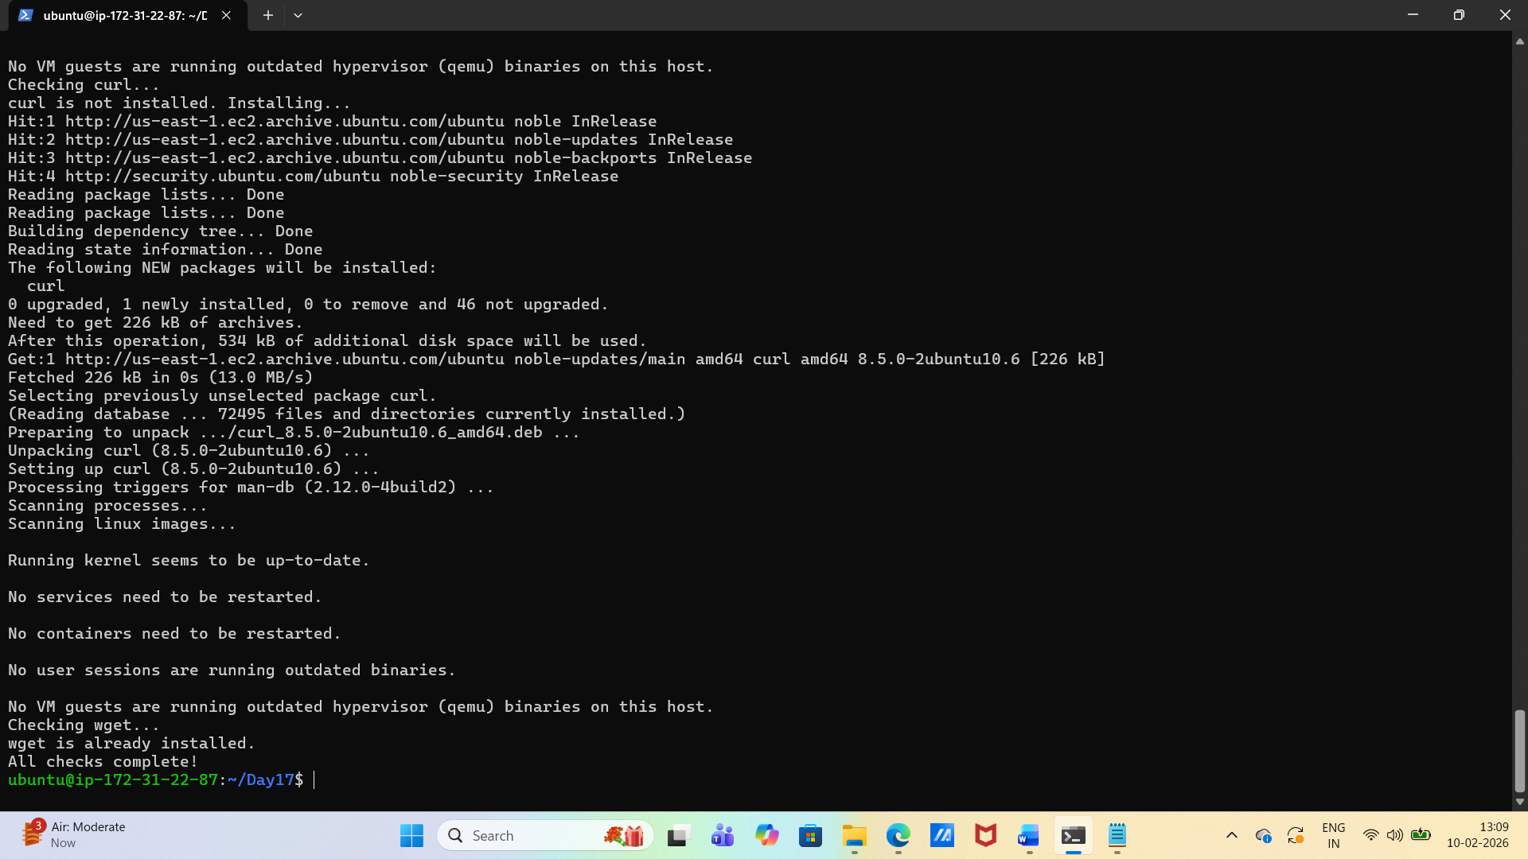

Task 5: Error Handling
- Create safe_script.sh that:
  - Uses set -e at the top (exit on error)
  - Tries to create a directory /tmp/devops-test
  - Tries to navigate into it
  - Creates a file inside
  - Uses || operator to print an error if any step fails
Example:
mkdir /tmp/devops-test || echo "Directory already exists"

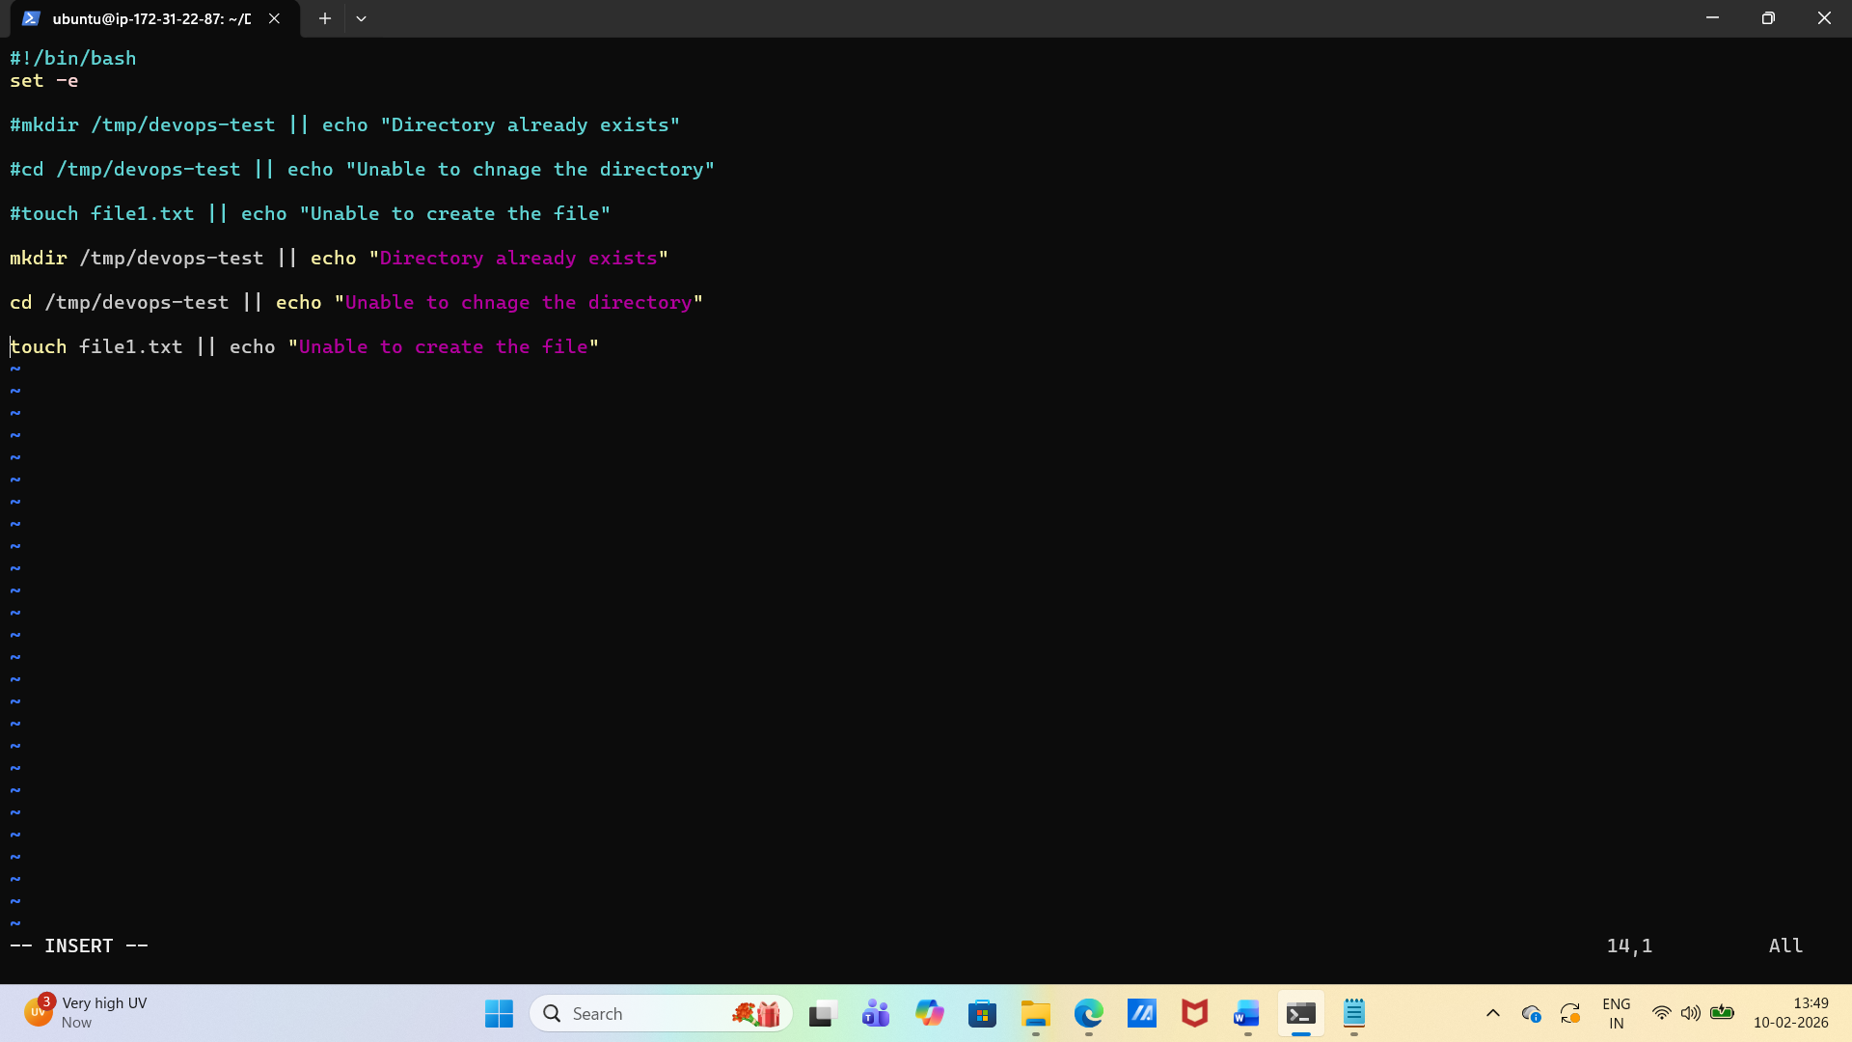

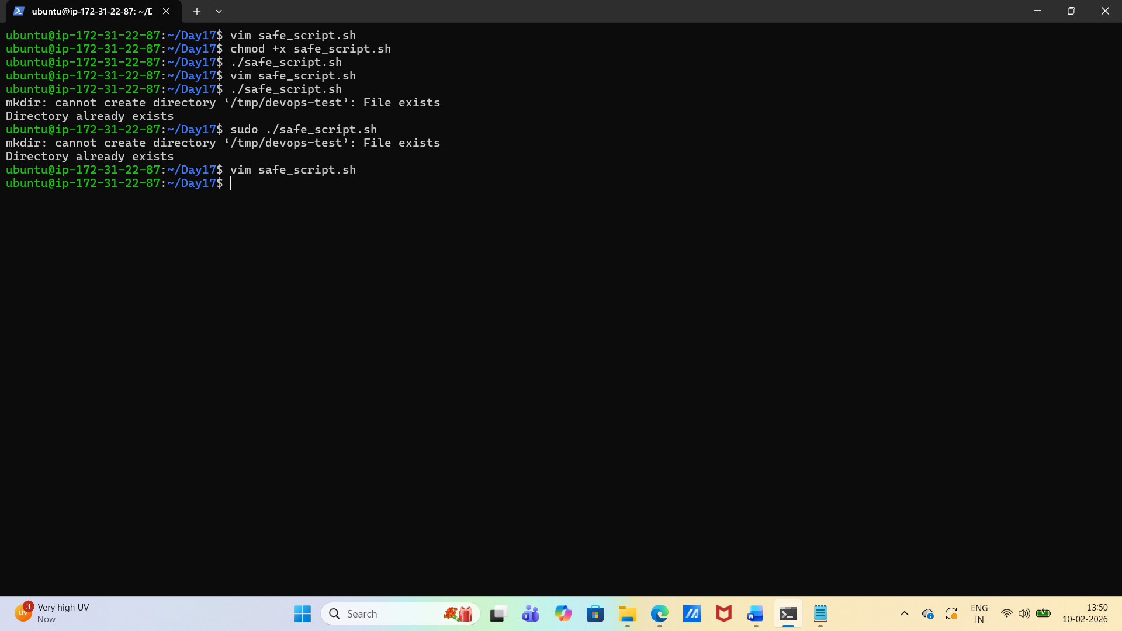

- Modify your install_packages.sh to check if the script is being run as root — exit with a message if not.

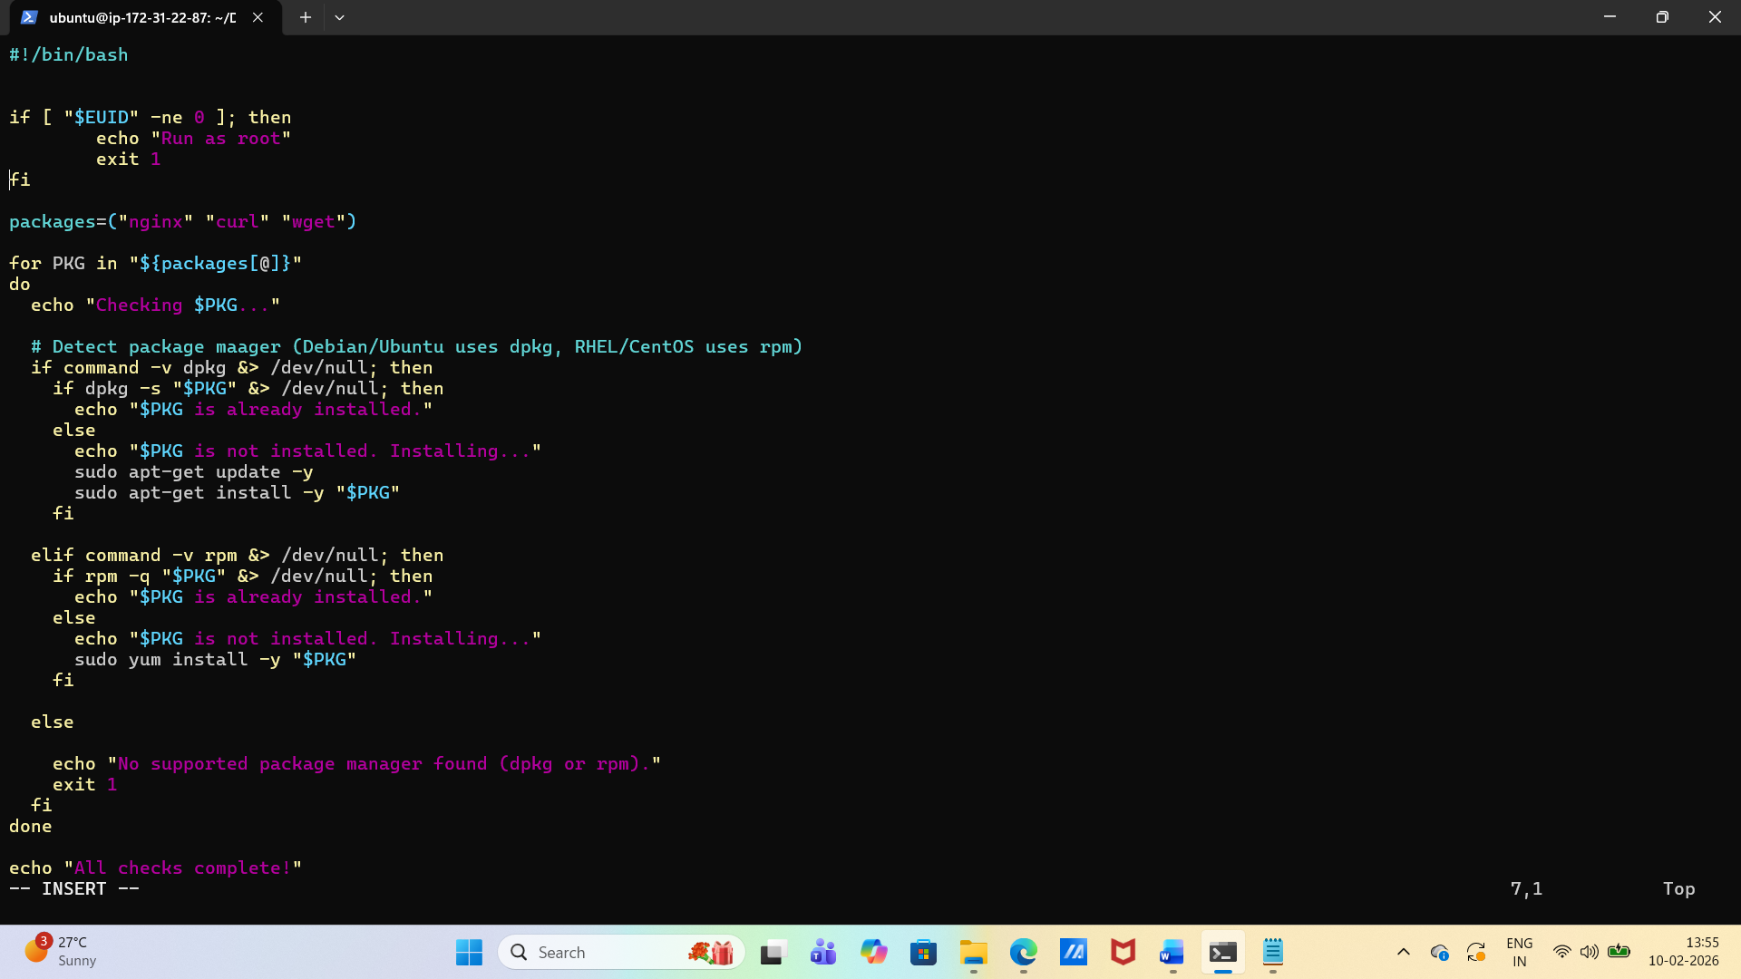

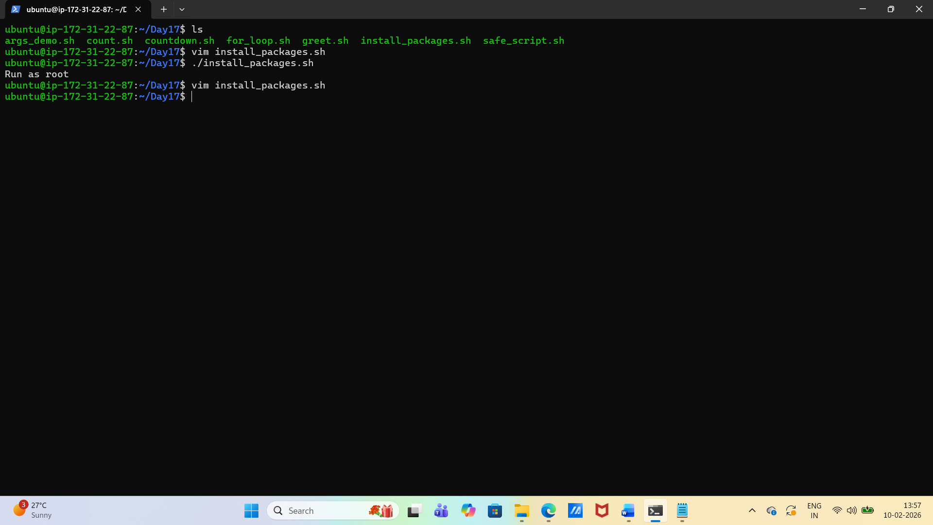

- "$EUID" is the effective user ID of the person running the script.
- 0 is the user ID for root.
- -ne 0 checks if the ID is not equal to 0 (i.e., not root).
- If true, it prints "Run as root" and exits with status code 1.

